
PAP-0808/PAP-1608/PAP-1616

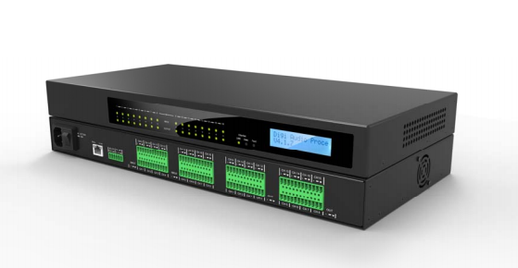

Product features:
High-performance floating-point DSP processing chips;
16 channel balanced audio input channels
All input channels to support MI c input
All input channels to support 48V phantom power
16 balanced audio output channel

Specifications:

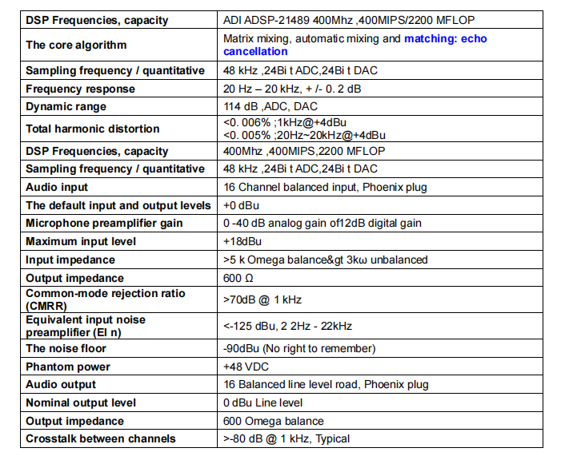


Web: www.surpass-audio.com; Email: info@surpass-audio.com Page 1/1

