
SP-PW530
Home Amplifier

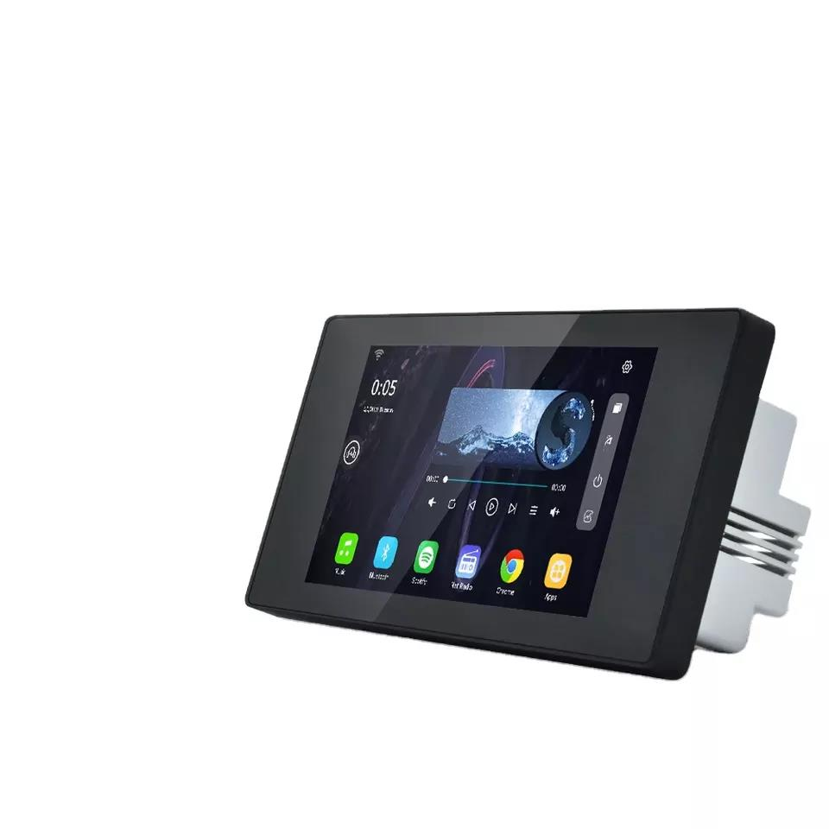

Features:
Wi-Fi, 5.5'' TFT display, 1280x800 resolution, 1G+8G memory, support Wi-Fi, android 8.1 system, 2*30W or 4x15W@8ohm, Two zone different volume control, RJ45, USB/TF, Audio in, Audio out, Smart home control with RS485 port. AC110-250V, with standard silver color cover, metal wire box
Specifications:
item | value
Brand Name | SURPASS
Model Number | PW530
Type | Home Amplifier
Channels | 4
Place of Origin | China
Output Power | 4*15W/2*30W
Audio S/N Ratio | ≥98dB
Audio Zone | 2 zone for audio
RAM | 1GB
ROM | 8GB
Resolution | 1280*800
Operating System | Android 8.1
Wi-fi | 2.4G up to 20 meters
Wire Box Size | 160*77 *60mm
Dimension | 171.5*85.5 * 54.5mm


Web: www.surpass-audio.com; Email: info@surpass-audio.com Page 1/1

