
SP-SF4080
Mixer Amplifier
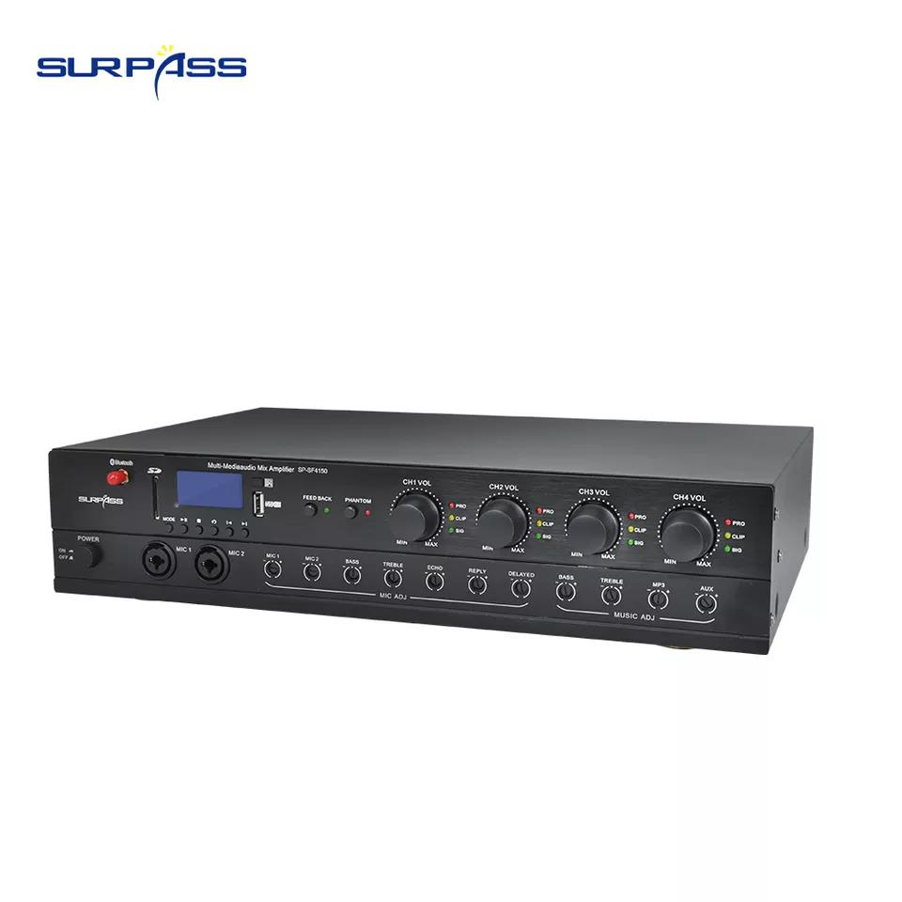

Features：
Input Type: Bluetooth, USB, Mp3, Line, Microphone, IR Remote Control
Line Input: AUX1/AUX2
Sensitivity: 500mV
Microphone input: MIC1 (priority), MIC2-6
Sensitivity: 10mV
Output Impedance: 8Ω/4Ω
Frequency response: 20Hz-20KHz (1KHz/≤0.1%THD)
Signal-to-noise ratio: >92dB
Channel separation: >50dB
Other functions: 48V phantom power, feedback suppression
Input power: AC90V~240V, 50Hz/60Hz
Aluminum Panel
Production Dimension: 430*320*80mm
Package Size: 545*380*150mm


Web: www.surpass-audio.com; Email: info@surpass-audio.com Page 1/1

