
SP-PS315
Wall-mount Speaker

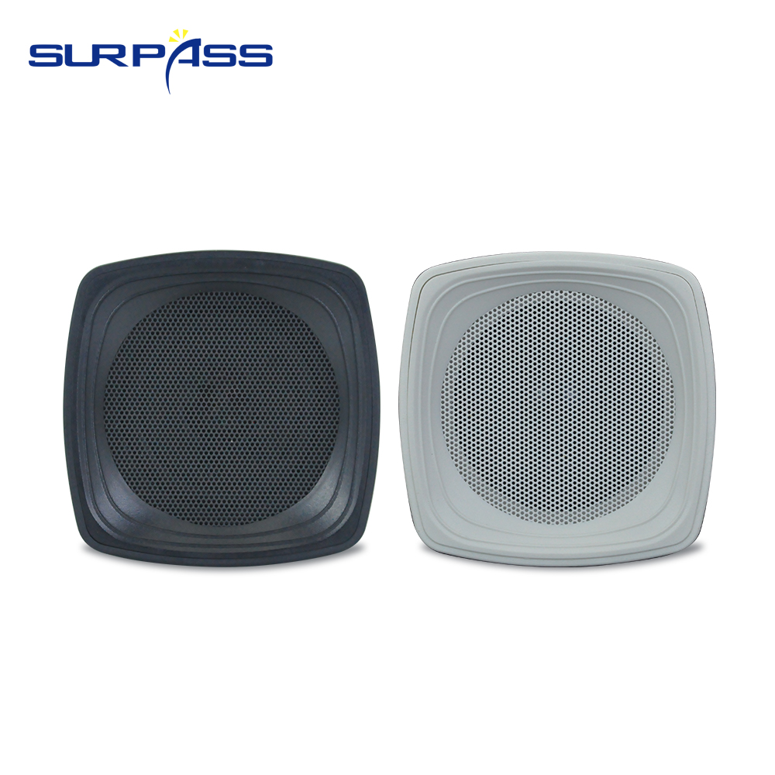

Features:
● Rated Power: 15W
● Power Taps: 15W-10W-5W-2.5W /8Ω
● Line Voltage: 100V
● Speaker Driver: 3'' full range
● Sensitivity (1W/1m): 89±3dB
● Frequency Response: 100-20kHz
● Material: ABS
● Color: white or black
● Product Dimension: 105*105*162mm
● Net Weight: 1.7kg
● Packing Size: 190*190*200mm
Specification：
item | value
Power Source | None
Battery | NO
Number of Loudspeaker Enclosure | 1
Audio Crossover | Full-Range
Set Type | Speaker
Speaker Type | OUTDOOR SPEAKER
Cabinet Material | Plastic
Display Screen | NO
Intelligent Personal Assistant | None
Built-in Microphone | NO
Brand Name | SURPASS
Model Number | SP-PS315
Type | Passive
Use | Office
Special Feature | Mini
Place of Origin | China
 | Guangdong
Rated Power | 15W
Power Taps | 15W-10W-5W-2.5W /8 Ohm
Line Voltage | 100V
Speaker Driver | 3'' full range
Sensitivity (1W/1m) | 89±3dB
Frequency Response | 100-20kHz
Material | ABS
Product Dimension | 105*105*162mm
Net Weight | 1.7kg
Packing Size | 190*190*200mm


Web: www.surpass-audio.com; Email: info@surpass-audio.com Page 1/1

