
SP-PW4420B
Home Amplifier

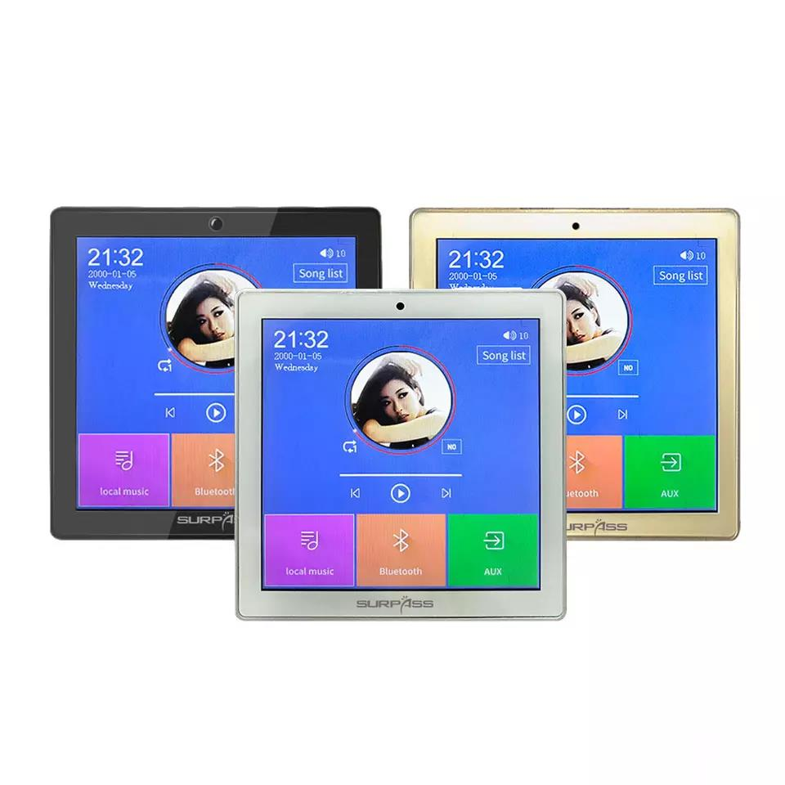

Features:
(Black/White/Gold) Capacitance Full Screen Touch 4 '' IPS display, 480x480 resolution, 4x20W@4-8ohm, Bluetooth, USB/TF, Video player, Radio function, Audio in, Audio out, Timing output, timer function, Door bell, support power-off memory, power-on and trigger music play, sound regulation, remote control. AC110-250V, with standard cover.
Specification：
item | value
Certification | ce, RoHS, FCC
Brand Name | SURPASS
Model Number | SP-PW4420B
Type | Home Amplifier
Channels | 4.4
Place of Origin | China
Type | Class D Digital Stereo AMP
Name | 4 inch Full Touch Screen Power Amplifier
Maximum Power Per Channel | 20W
RMS Output Power | 4*20W
Power Supply | AC110V-250V
Zone Volume Control | 2 zones
Wi-Fi | 8-10m
Resolution | 480*480
Frequency Range | 20Hz-20KHZ
Dimension | 86*86*52mm


Web: www.surpass-audio.com; Email: info@surpass-audio.com Page 1/1

