
SP-BTF22
In-ceiling speaker

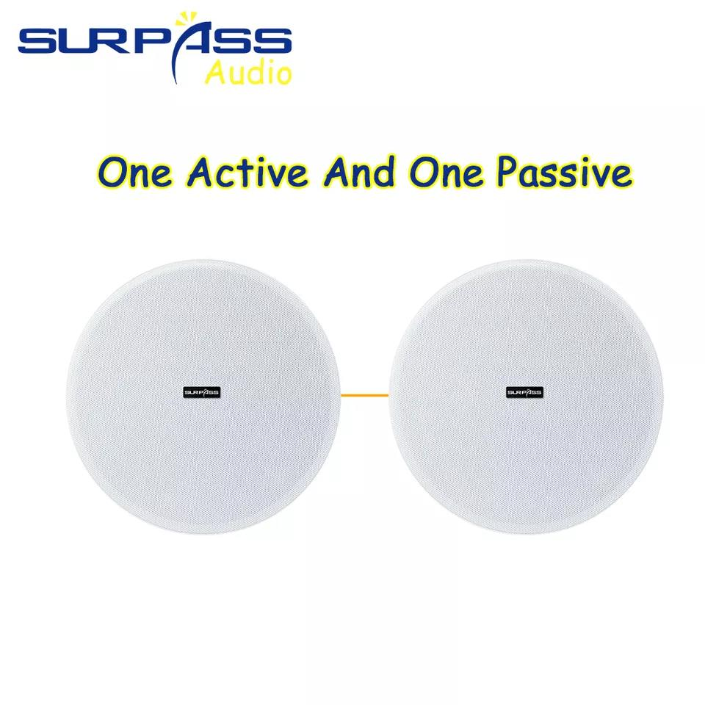

Features:

5.25 Inch Wireless Active 30W Blue-tooth Coaxial Frameless Ceiling Speaker Master Ceiling Speaker With 1 Slave Ceiling Speaker
5.25'' Frameless Coxial Ceiling Speaker with Magnetic Grill 2pcs/set ▪ Rated Power: 2x30W ▪ Peak Power: 2x60W ▪ Frequency response: 55-22Khz ▪ Impedance: 8Ω ▪ Sensitivity: 89dB ▪ Amplifier Module: 2x30W/Class D digital power amplifier module ▪ Support Blue-tooth Protocol: HFPV1.5, A2DPV1.2,AVRCPV1.4，HSP1.2, GAVDP1.2，IOP ▪ Speaker Unit:Integration 5.25"Coaxial unit ▪ Installation: Ceiling mount ▪ Decorative materials: ABS ▪ Power In: 24V2A ▪ Product size: 206x80mm ▪ Opening hole size: Φ180 ▪ Weight: 3kg (2pcs/set)

Specification:
tem | value
Battery | NO
Number of Loudspeaker Enclosure | 1
Audio Crossover | TWO-WAY
Woofer Size/Full-Range Size | 5.25"
Material | Plastic
Communication | AUX
Speaker Type | In-ceiling Speaker
Remote Control | Yes
Cabinet Material | Plastic
Tweeter Size | 1"
Brand Name | SURPASS
Model Number | SP-BTF22
Type | Active
Use | HOME THEATRE, Party
Channels | 1
Place of Origin | China
 | Guangdong
Rated Power | 2x30W
Peak Power | 2x60W
Frequency response | 70-20Khz
Sensitivity | 89dB
Amplifier Module | 2x30W/Class D digital power amplifier module
Support Blue-tooth Protocol | HFPV1.5, A2DPV1.2,AVRCPV1.4,HSP1.2, GAVDP1.2,IOP
Speaker Unit | Integration 5.25"Coaxial unit
Product size | 206x80mm
Power In | 24V2A
Weight | 3kg (2pcs/set)


Web: www.surpass-audio.com; Email: info@surpass-audio.com Page 1/1

