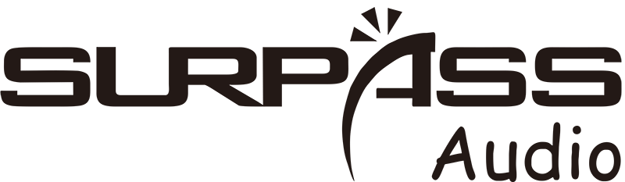
SP-A8
Trolley Speaker

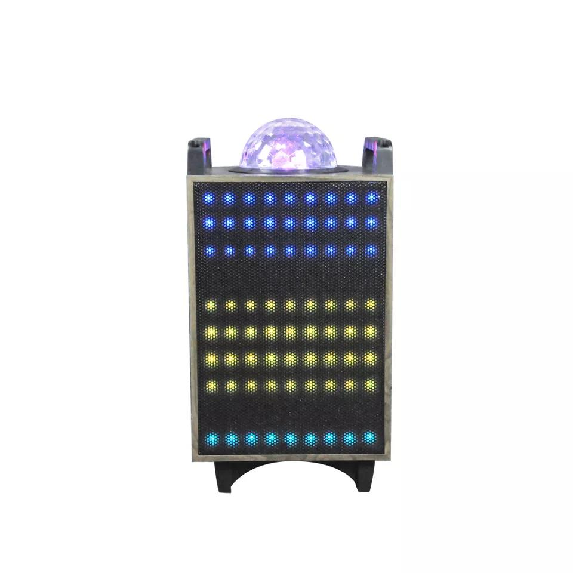

Features:
1. The box is made of wooden material, the front of the product is protected by iron mesh, with 90 spectrum lights (6 lighting modes). There is a large lamp ball on the top of the box, and handles on both sides of the top.
2. Built-in 12V7A battery, can be connected to an external 12V power supply.
3. The function is operated on the side of the box. With LED digital display, support USB/TF card input, with Bluetooth, FM, recording, TWS function, recording deletion, indoor and outdoor switching sound effects. 8 functional buttons. with remote control.
4. Support one channel of musical instrument input, the volume of the instrument can be adjusted independently
5. Support one channel of wired microphone input. Microphone volume and reverb are independently adjustable. With microphone priority function
6. Support 3.5AUX signal input
7. Rated Power: 70W, maximum power: 300W
8. Speaker: Bass 10 inch 100C*1, 3 inch coil mid-treble
9. Equipped with 2 LED display wireless microphones .
10. 15V2A adapter charging
Specification:
item | value
Place of Origin | China
Brand Name | SURPASS
Model Number | A8
Warranty | 3months-1year
Customized | Yes
Battery | 12V7A
Signal Input | 3.5AUX
Rated Power | 70W
Maximum Power | 300W
Speaker Unit | Bass 10 inch 100C*1, 3 inch coil mid-treble
Communication | TF/FM/USB/Blue-tooth
Enclosure | 2 LED display wireless microphones
Charge Adapter | 15V2A
Function | recording, TWS function, recording deletion
Gross Weight | 16KG


Web: www.surpass-audio.com; Email: info@surpass-audio.com Page 1/1

