
SP-WCH03
Wireless Charger

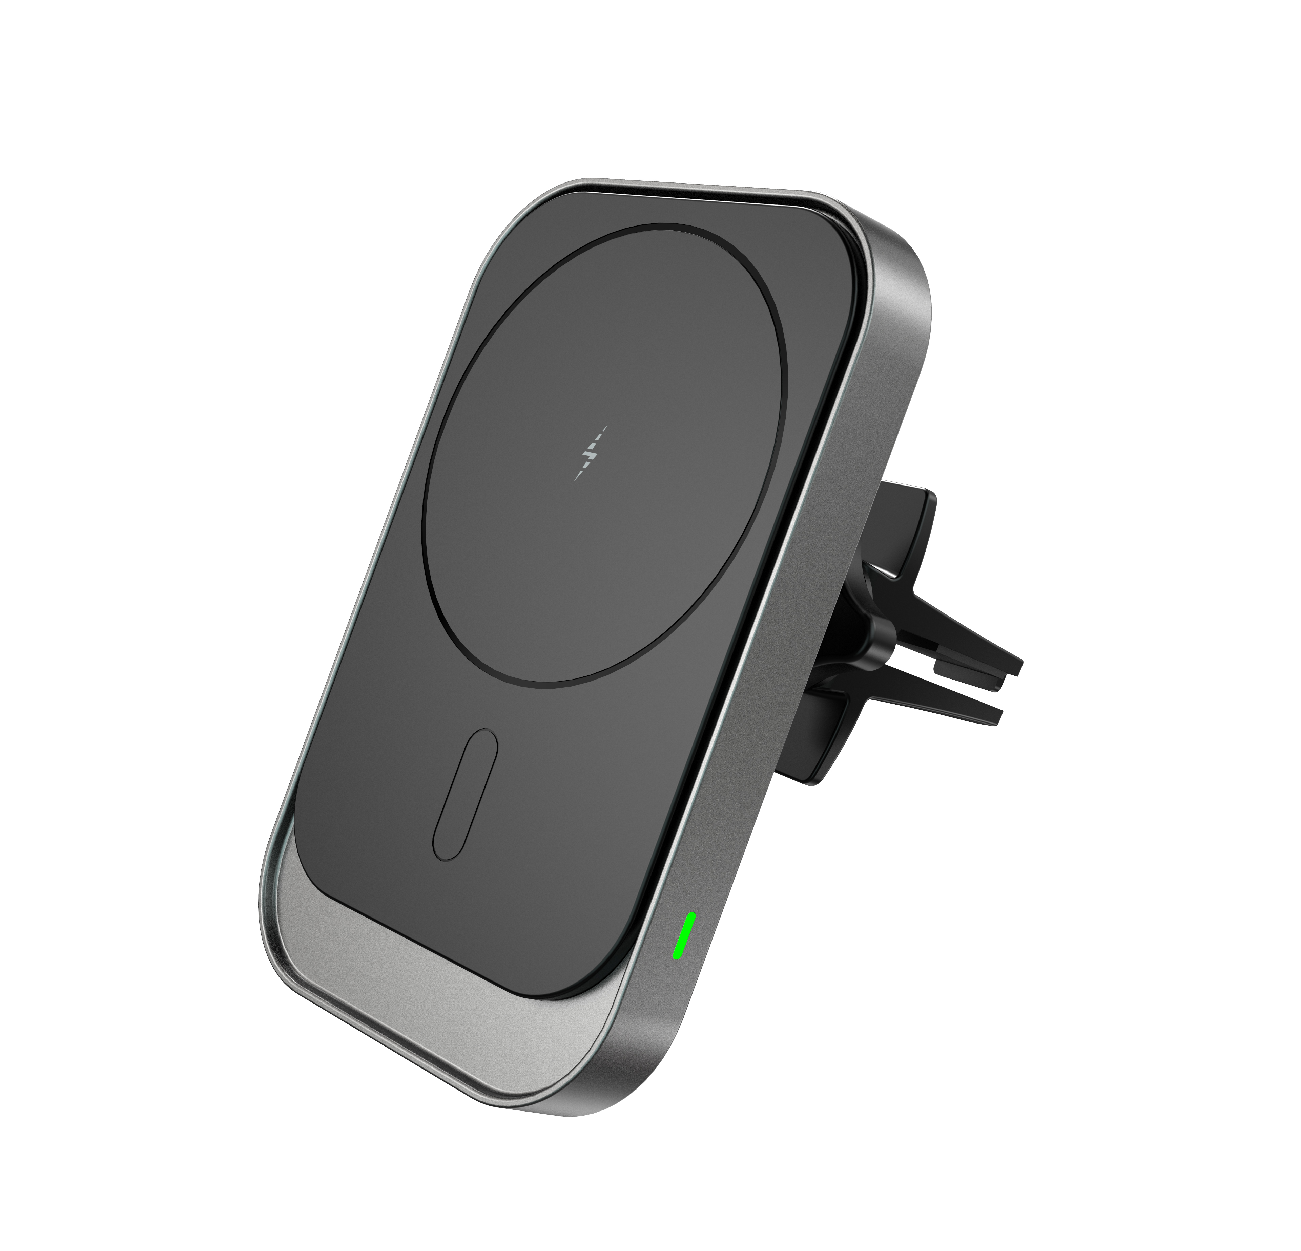

Features:
The trend of wireless charging technology is truly born for cars resulting in bidding farewell to the troubles of wired charging. Built-in multi -point pos itioning and charging, the mobile phone and the base are magnetically attracted to fit firmly. Rotate at any angle of 360°, 15W super-large coil, more powerful charging, allowing you to drive safely, conveniently and easily, and you can bring it wherever you go. Not only for the car, but also for the convenience of life and c reation, and bid farewell to cumbersome from now on.
Specification：
item | value
Type | Electric, Wireless Charger, CAR CHARGER, Fast Charger
Usage | Mobile Phone
Material | ABS+PC
Function | Qi
Brand Name | SURPASS
Model Number | SP-WCH03
Place of Origin | China
 | Guangdong
Model | WCH03
Product size | 102*74*65mm
Material | ABS+PC
Colour | Black
Input power | 5V/2A 9V/2A
Output power | 15W(MAX)
Effective distance of wireless charging | 3~6mm
Conversion efficiency | ≥ 70%
Working frequency | 110-205KHz
Clip | Knob screw clip(clamp firmly)


Web: www.surpass-audio.com; Email: info@surpass-audio.com Page 1/1

