
SP-CS05
Clock Speaker
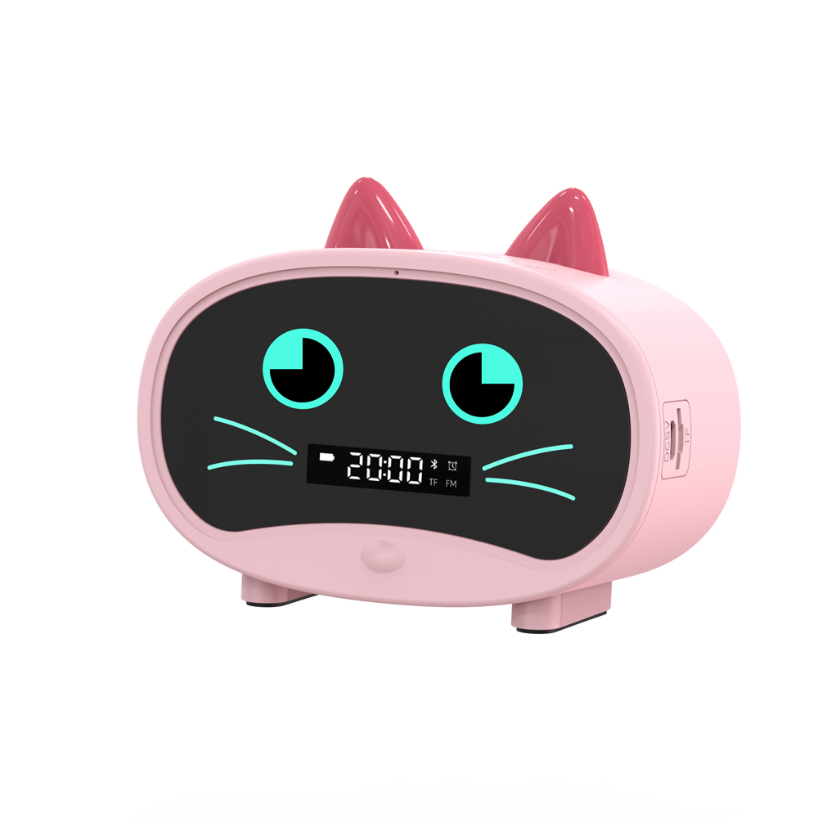

Features:
Color: white, pink, blue
Input voltage: DC5V/1A
Output power: 3-10W THD=10%
Frequency response: 120Hz-20kHz
Speaker: 4Ω 5W
Radio frequency: 87-108MHz
Radio sensitivity:>20dB
Bluetooth version: 5.0
Battery specification: 3.7V 1400MAH
Signal-to-noise ratio: >80dB
Product size: 118*48.5*88mm
Net weight: 240g
Packing size: 130*54*95mm
Packing weight: 300g
Specification：
item | value
Brand Name | SURPASS
Model Number | SP-CS05
Place of Origin | China
 | Guangdong
Product Type | Alarm Clock
Battery specification | 3.7V 1400MAH
Temperature range | Temperature range
Color | white, pink, blue,
Product size | 118*48.5*88mm
Product weight | 240g
Packing weight | 300g
Packing size | 130*54*95mm


Web: www.surpass-audio.com; Email: info@surpass-audio.com Page 1/1

