
SP-CS08
Clock Speaker
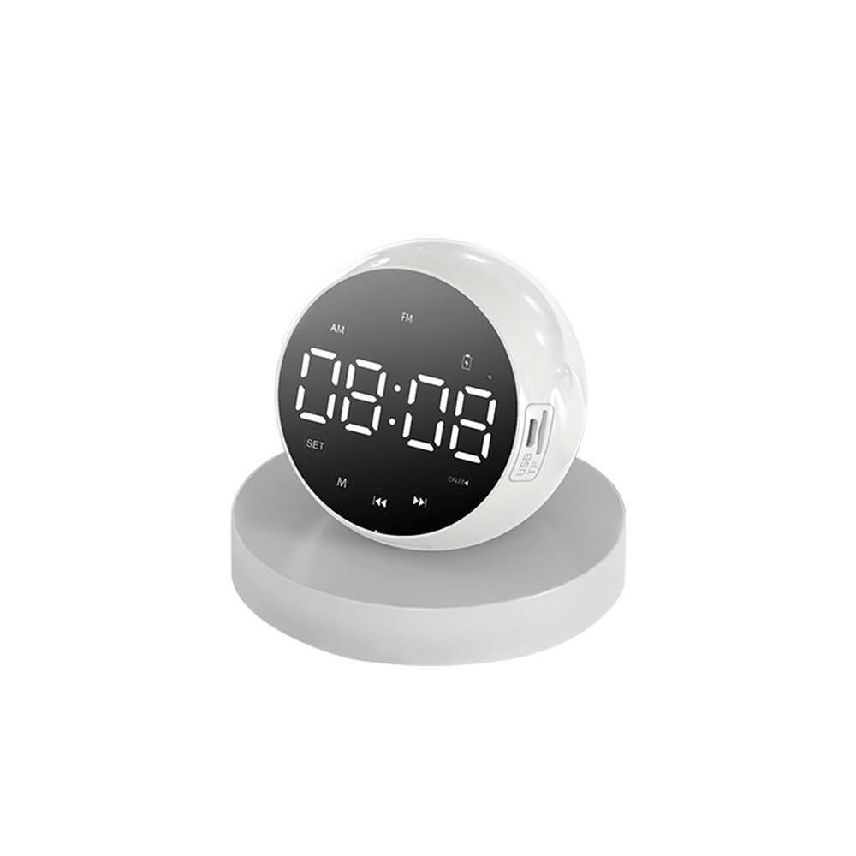

Features:
Color: white, black
Input voltage: DC5V/1A
Output power: 3W THD=10%
Frequency response: 80Hz-20kHz
Speaker: 50mm 4Ω 3W
Radio frequency: 87.5-108MHz
Distortion: <0.5%
Bluetooth version: 5.0
Battery specification: 3.7V 1200MAH
Signal-to-noise ratio: ≥80dB
Product size: 89.5*63*79mm
Net weight: 160g
Packing size: 95*90*95mm
Packing weight: 210g
Specification：
item | value
Brand Name | SURPASS
Model Number | SP-CS08
Place of Origin | China
 | Guangdong
Product Type | Alarm Clock
Battery specification | 3.7V 1200MAH
Temperature range | Temperature range
Color | white, black,
Product size | 89.5*63*79mm
Product weight | 160g
Packing weight | 210g
Packing size | 95*90*95mm


Web: www.surpass-audio.com; Email: info@surpass-audio.com Page 1/1

