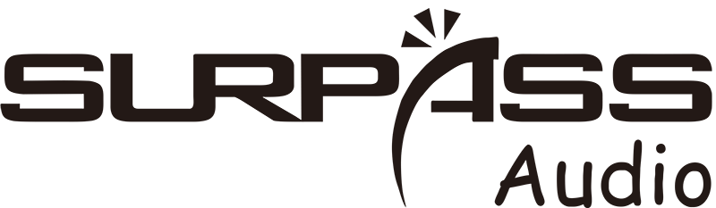
SP-CS09
Clock Speaker
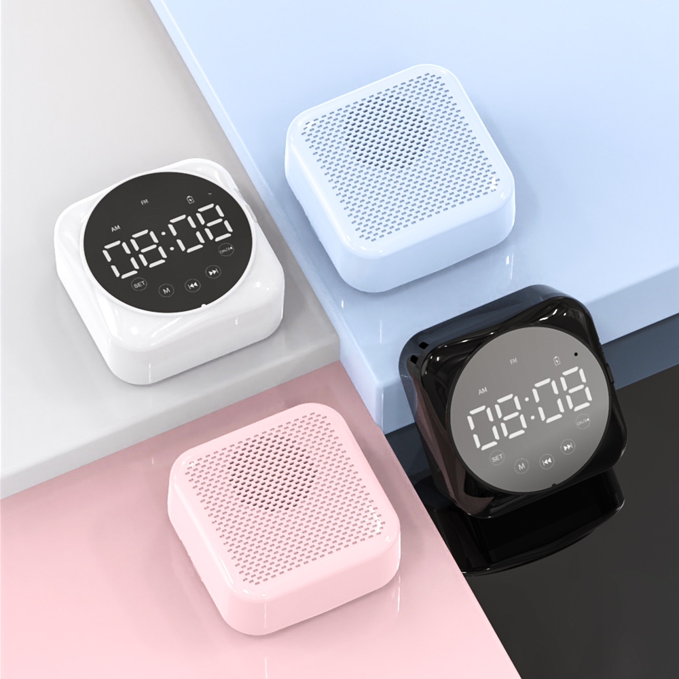

Features:
Charging interface: USB 5V/1A
Output power: 3W THD=10%
Frequency response: 80Hz-20kHz
Speaker: 40mm 4Ω 3W
Bluetooth version: 5.1
Bluetooth distance: 15M
Battery specification: 1200mAh 18650
Standby time: 24 months
Music continuous playback time: 4 hours
Continuous working time in clock mode: 85 hours
Working temperature: -40℃ +85℃
Material: ABS+PVC display panel
Product size: 80*80*39mm
Net weight: 140g
Packing size: 101*101*42mm
Packing weight: 200g
Specification：
item | value
Brand Name | SURPASS
Model Number | SP-CS09
Place of Origin | China
 | Guangdong
Product Type | Alarm Clock
Battery specification | 1200mAh 18650
Temperature range | Temperature range
Color | white, black,
Product size | 80*80*39mm
Product weight | 140g
Packing weight | 200g
Packing size | 101*101*42mm


Web: www.surpass-audio.com; Email: info@surpass-audio.com Page 1/1

